**PLOTS**

**HISTOGRAM PLOTS:**

A histogram is a graphical representation commonly used to visualize the distribution of numerical data.

Consider the **dataset Iris.**

**HISTOGRAM FOR SEPAL LENGTH**:

hist(iris$Sepal.Length ,main="Histogram of sepal length",xlab="sepal length")

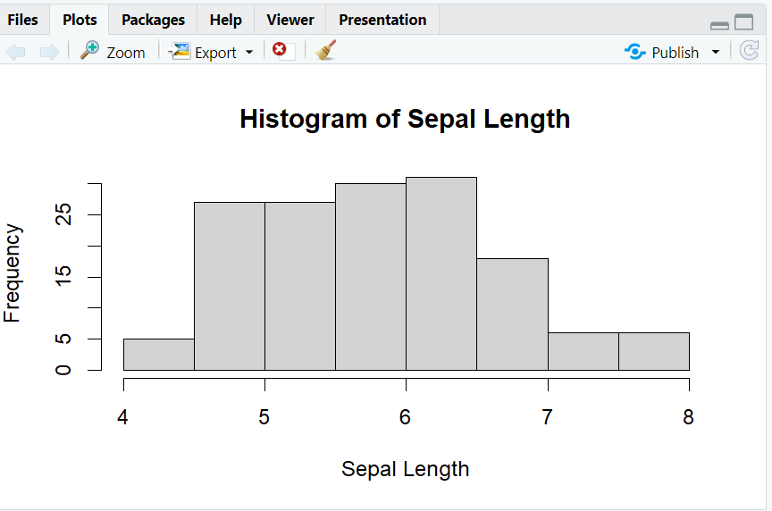

**HISTOGRAM FOR SEPAL WIDTH:**

hist(iris$Sepal.Width ,main="Histogram of sepal width",xlab="sepal width")

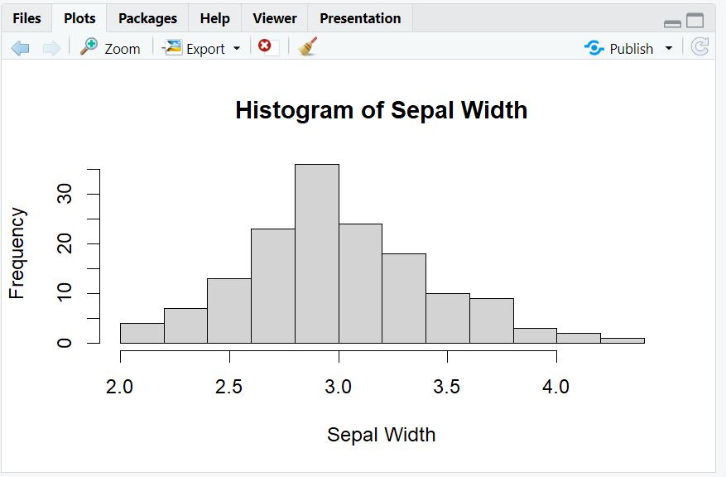

**HISTOGRAM FOR PETAL LENGTH:**

hist(iris$Petal.Length ,main="Histogram of petal length",xlab="petal length")

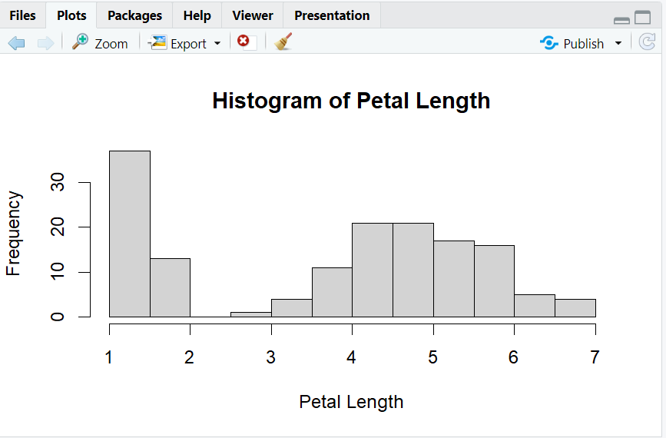

**HISTOGRAM FOR PETAL WIDTH:**

hist(iris$Petal.Width ,main="Histogram of petal width",xlab="petal width")

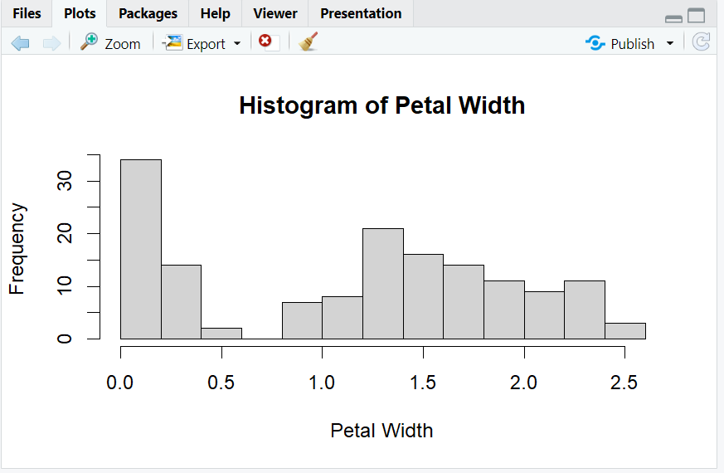

**BOXPLOTS:**

A box plot is a chart that is used to display information in the form of distribut-ion by drawing boxplots for each of them. This distribution of data is based on five sets -minimum, first quartile, median, third quartile, and maximum.

BOXPLOT FOR SEPAL LENGTH:

boxplot(Sepal.Length ~ Species, data=iris, main="Boxplot of sepal length by

Species", xlab="Species", ylab="sepal Length")

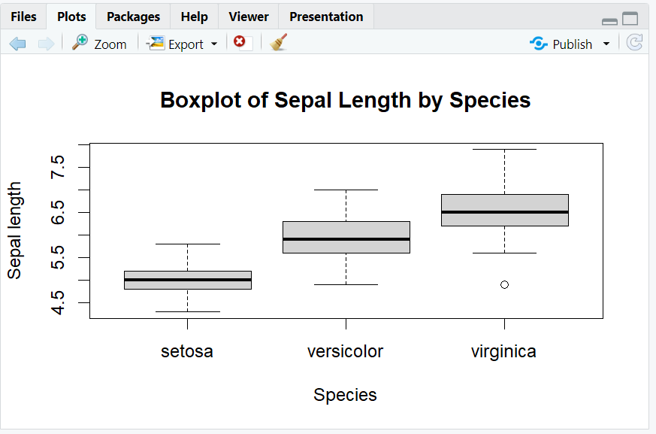

BOXPLOT FOR SEPAL WIDTH:

boxplot(Sepal.Width ~ Species, data=iris, main="Boxplot of sepal width by

Species", xlab="Species", ylab="sepal Width")

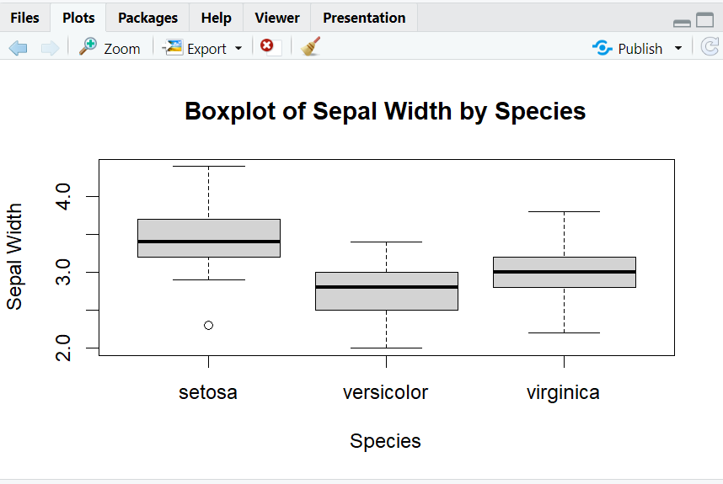

BOXPLOT FOR PETAL LENGTH:

boxplot(Petal.Length ~ Species, data=iris, main="Boxplot of Petal length by

Species", xlab="Species", ylab="Petal Length")

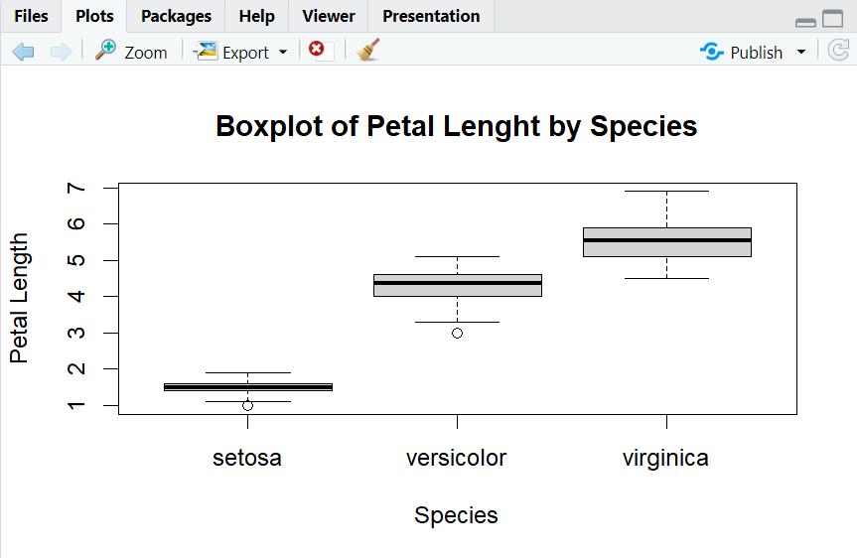

BOXPLOT FOR PETAL WIDTH:

boxplot(Petal.Width ~ Species, data=iris, main="Boxplot of Petal Width by Species", xlab="Species", ylab="Petal Width")

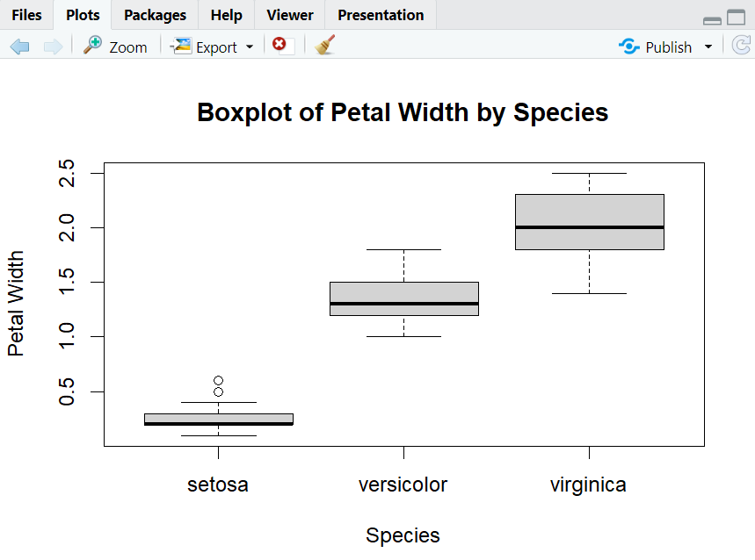

**SCATTER PLOT:**

A "scatter plot" is a type of plot used to display the relationship between two numerical variables, and plots one dot for each observation.

SCATTER PLOT FOR SEPAL:

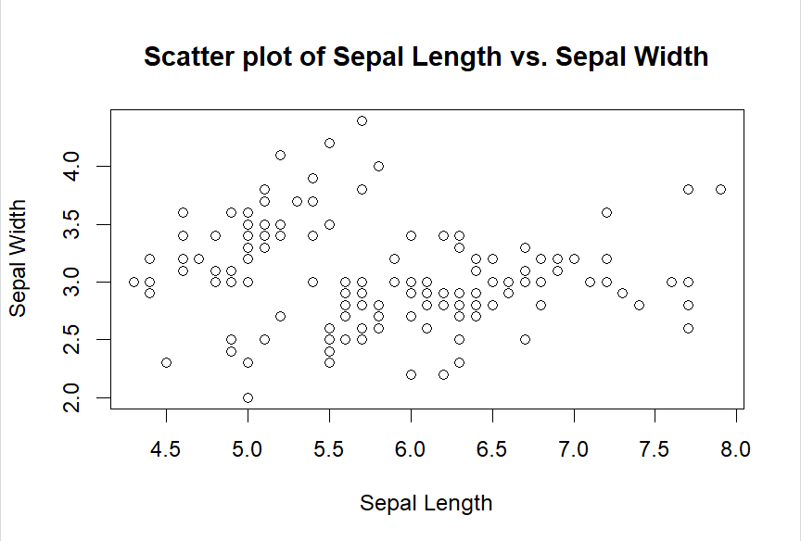

SCATTER PLOT FOR PETAL:

plot(iris$Petal.Length, iris$Petal.Width, main="Scatter plot of petal Length vs. petal Width", xlab="Petal Length", ylab="Petal Width")

